I. NATIONAL ATLAS - http://nationalatlas.gov: This site is useful for visualizing environmental factors using map overlays. You can make and download your own maps on this site.

- On the homepage click on Map Maker in the banner.

- Be sure to fully expand and explore the Map Layers. In these layers you will find environmental variables that you may want to correlate with data on WNV incidence in humans, birds, and mosquitoes found on other web sites. Breeding bird survey routes and average annual precipitation are also included, but these factors are discussed in more detail on the other web sites. Land cover for the bird survey routes is on that site (BBS).

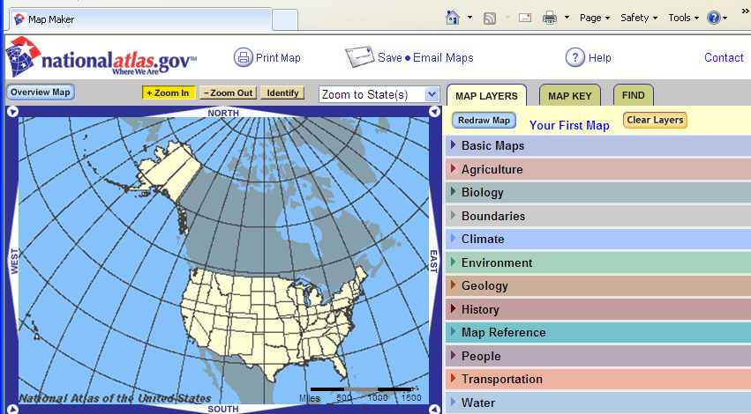

- In Map Layers, check the box for each item you want mapped, then click Redraw Map. If you want to remove a layer and add a different layer, first uncheck the box, then click Redraw Map, then check the new box and Redraw Map again. If you want to clear all of the layers, click Clear Layers. You can add any number of layers, but you will find the maps hard to read if you add too many.

- After drawing a map, you can use the Zoom to States pull down menu to view the entire US or any state for the map. Note that you can continue to zoom in. You can move back and forth between Find and Map Layers to zoom in and out and to view different places; however, remember to Clear Layers before choosing a different data set to be mapped, as opposed to viewing a different locality or state on a map already drawn.

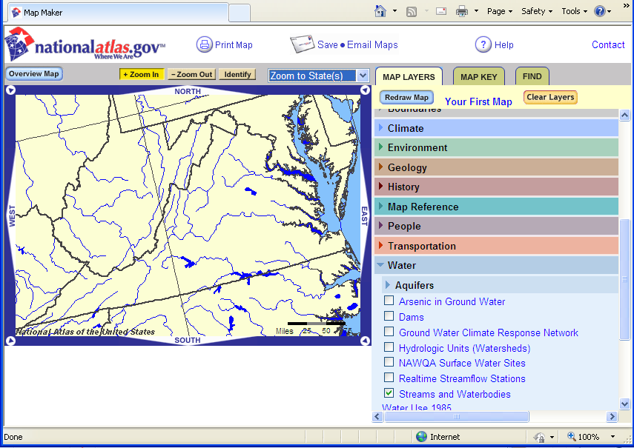

- The Map Key tab will show keys for every layer on your map. Some layers will obscure each other. In red in the Map Key tab you are warned when one layer is covering another.)

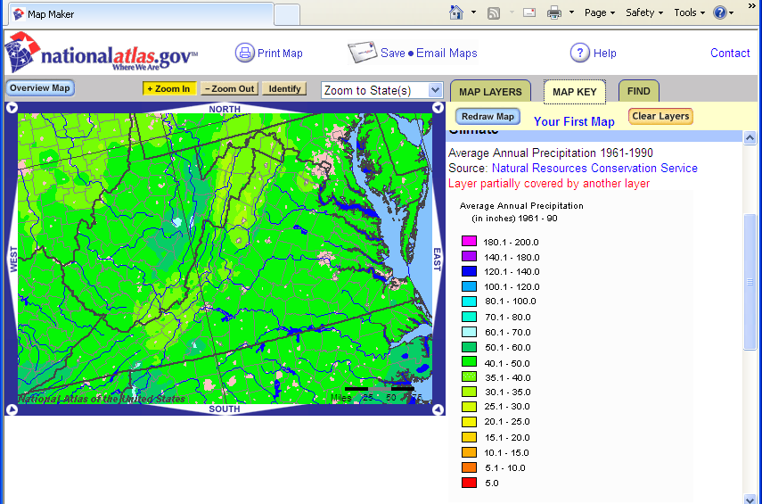

- The Find tab can be used to locate your home town or county.

- Once you have entered your home town or county, you can view aerial photos or topographic maps for your hometown by using the zoom feature. This will allow you to see the environmental conditions at a smaller scale as you view your chosen map layers.

